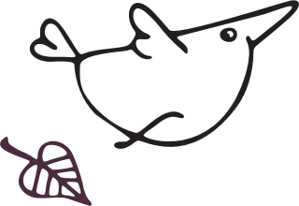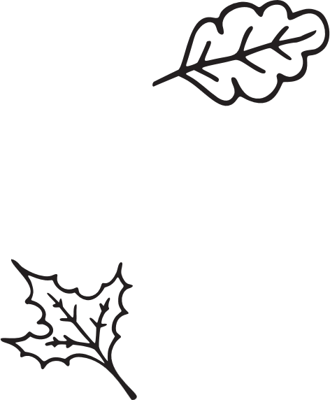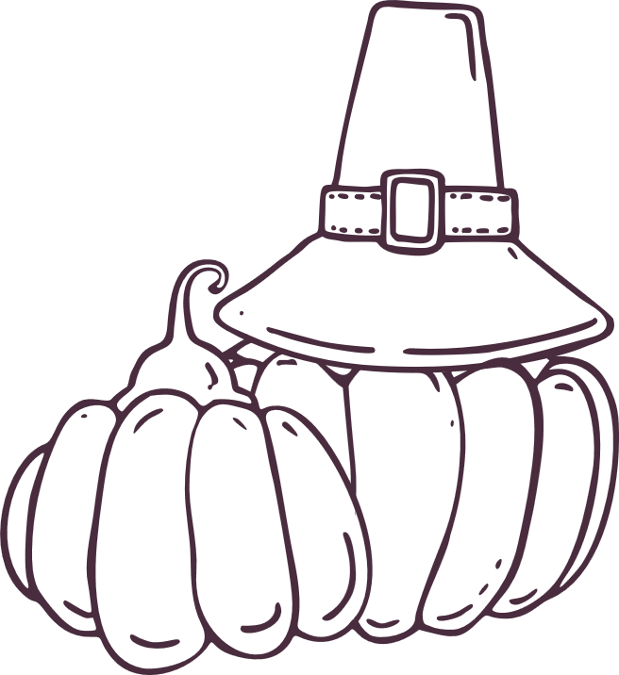

|  |
| --- |
| Hire artist for your next game! |
| We’re a group of artists We specialize in 3D art, Pixel art and much more! |
| Contact: art@mujtaba.comThank you! |
| 63 street, E-15  Visit our Office1 |